# General Setup

Go to <https://github.com/> and make a GitHub account if you don’t have one yet.

Send your email address and username used for the GitHub account to the repository (GitHub project) owner and request to be added to the repository as a collaborator. Or ask him for an invite link.

Install SourceTree from <https://www.sourcetreeapp.com/>

Login to bitbucket with a bitbucket account to install the software when the installer asks for it.

Once the installer is done start up SourceTree.

To login to GitHub through source tree click **Remote**.

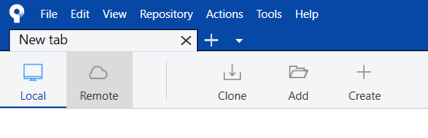

Click on Add Account.

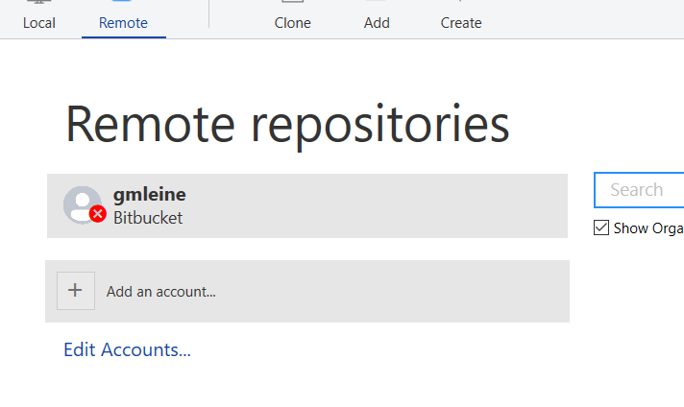

From the Hosting Service dropdown, select GitHub:

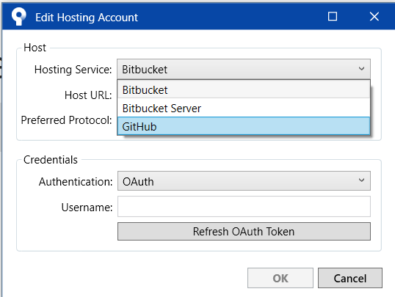

From Credentials Select Basic:  
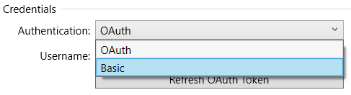

Login by typing in your GitHub name and clicking Refresh Password:  
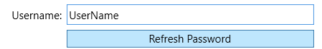

Click okay To exit.

To connect to our repository, click on **Clone**.

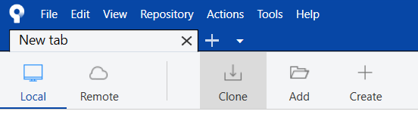

Ask the repository owner for the repository link and copy it into the top text bar.  
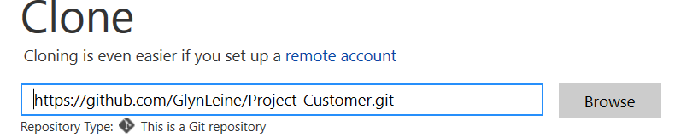

User/SomeRepository.git

On the second text bar click Browse and select a folder where you want the project to download to. This will also be the folder where you will work on the project. Make sure that this is an empty folder.

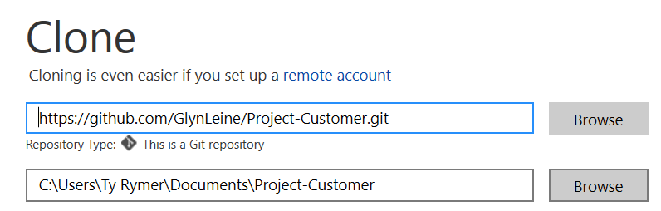

When you’re done with everything click Clone and everything should be set up.

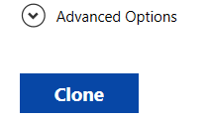

# Universal

1. ***Root\.gitignore*** should be set as the git ignore file. If all is okay this should be set by default.

# Art

1. Unfinished art should be saved in the dedicated Maya, Photoshop and Substance folders. If an extra folder is needed for other software, please create a new folder.

Finished art that’s ready for import should be exported from its respective software to the Root\Art\Ready For Import folder.

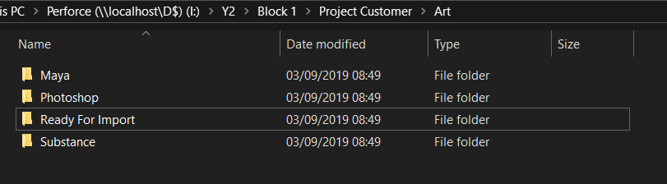

# Design

1. Design docs are all to be put into the Design Docs folder.

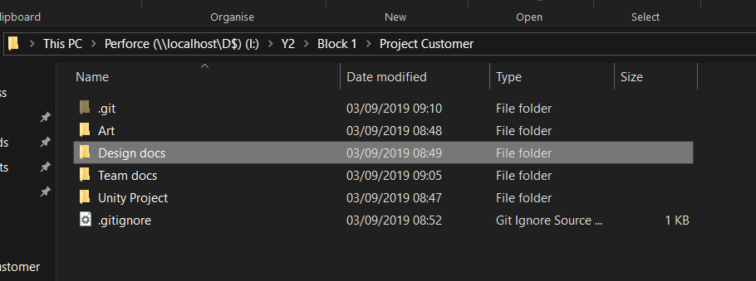

# Programming

1. Everything lives inside the Root\Art\Unity Project folder.
2. each script should be in the scripts folder.
3. attributes in the attributes folder.
4. editors in the editor folder.